## Project Name: Bank Management System

### Analysis and Design Phase

## Project Participants:

Muhammad Abdur Rehman (23-NTU-CS-1180)

### **Submitted to: Sir Arsal Mehmood**

# Chapter One

## Business Requirements and Rules

The proposed Bank Management System will provide two types of user roles: "**Agent**" and "**Admin**". Users and admins will have attributes including UserID, Username, Password, and Role. Each user can only have one role at a time.

Admins will have the authority to manage user accounts, including creating, or updating accounts. They can also oversee transactions, configure system settings, and manage other administrative tasks.

Users will have access to basic banking functionalities such as managing their accounts and performing transactions. They can create new accounts with various types of transactions including deposits, withdrawals, transfers, and payments.

The system will support secure authentication mechanisms to ensure that only authorized users can access sensitive functionalities and data. Access to certain functionalities and data will be restricted based on user roles.

## Business Rules

* Access to the system requires the input of a valid username, password, and role selection. Users with the correct credentials and role designation can access the system functionalities.
* Each account belongs to only one user, but a user can have multiple accounts.
* Users can perform various transactions such as deposits, withdrawals, transfers, and payments.
* User data, including personal information and financial transactions, is securely stored and protected from unauthorized access.
* The system supports two user roles: "**Agent**" and "**Admin**". Admins have elevated privileges and can access additional functionalities compared to regular users.
* The system must provide comprehensive error messages for each exception encountered. Error messages should be informative and user-friendly, aiding users in understanding and resolving issues.

## List Of Final Entities

* Person
* Agent
* Admin
* Account
* Transactions

## List of Final Relations

* Admin **Manages** Agents
* Admin **Manages** Accounts
* User **Contains** Accounts
* User **performs** Transactions
* Account **has** Transactions

## EERD

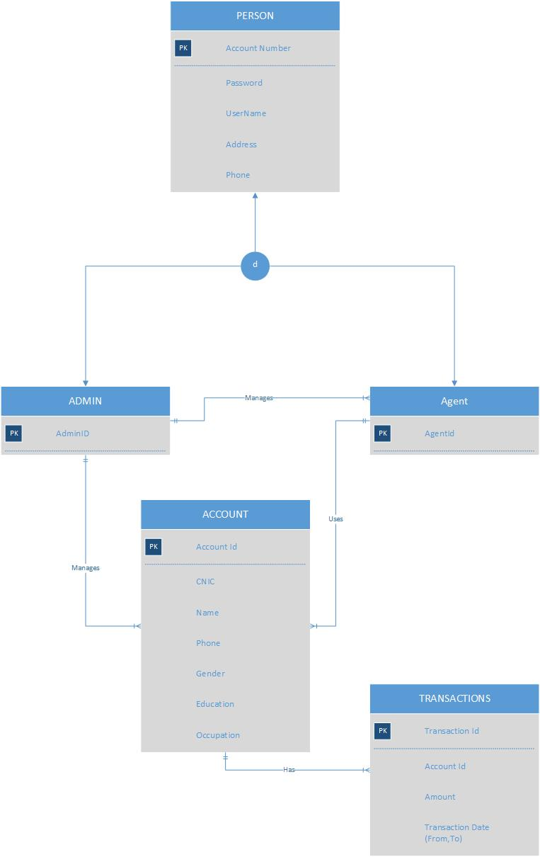

## Tables Converted from EERD

**Person**

|  |  |  |  |  |
| --- | --- | --- | --- | --- |
| Account Number | User Name | Password | Address | Phone |

**Admin**

|  |
| --- |
| Admin ID |

**Agent**

|  |
| --- |
| Agent ID |

**Account**

|  |  |  |  |  |  |  |
| --- | --- | --- | --- | --- | --- | --- |
| Account Number | CNIC | Name | Phone | Gender | Education | Occupation |

**Transaction**

|  |  |  |  |  |
| --- | --- | --- | --- | --- |
| TransactionId | Account Number | Amount | From date | To date |

## Chapter 2: Tables after 3NF

### 3NF

**Person**

|  |  |  |
| --- | --- | --- |
| Account Number | Address | Phone |

**Login**

|  |  |
| --- | --- |
| User Name | Password |

**Admin**

|  |
| --- |
| Admin ID |

**Agent**

|  |
| --- |
| Agent ID |

**Account**

|  |  |  |  |  |  |  |
| --- | --- | --- | --- | --- | --- | --- |
| Account Number | CNIC | Name | Phone | Gender | Education | Occupation |

**Transaction**

|  |  |  |  |  |
| --- | --- | --- | --- | --- |
| TransactionId | Account Number | Amount | From date | To date |

## Forms and forms layout

* Progress Bar Form

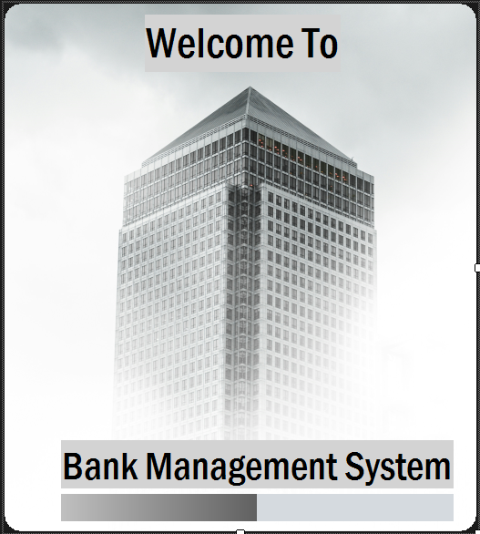

* Login Form

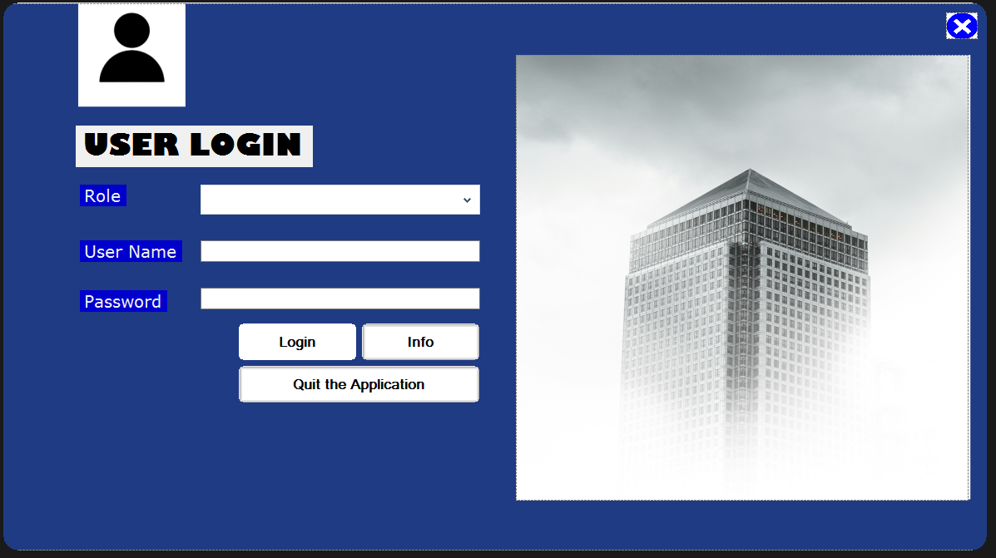

* Admin Panel Form

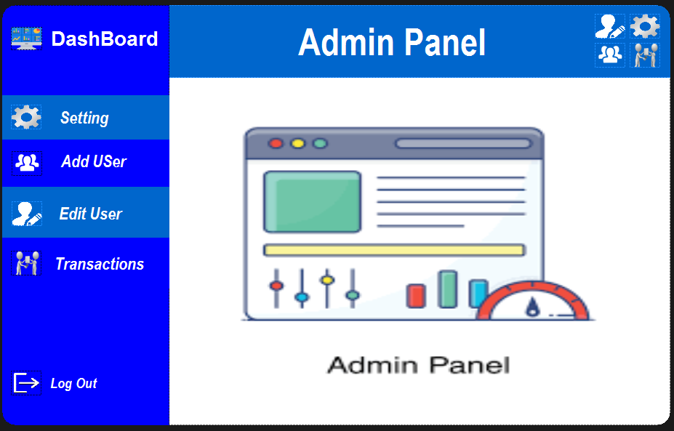

* Agent Panel Form

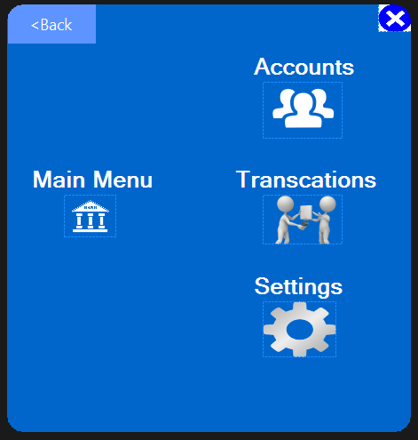

* Register New User Form

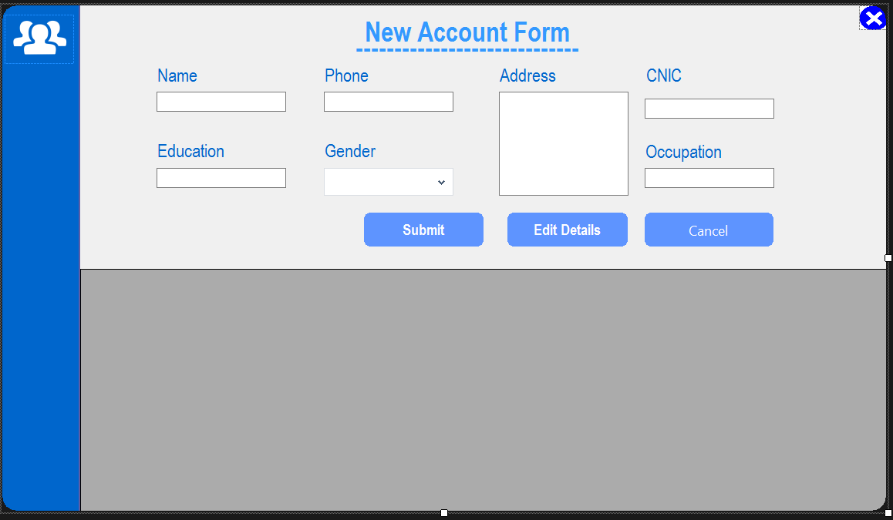

* Edit User Info

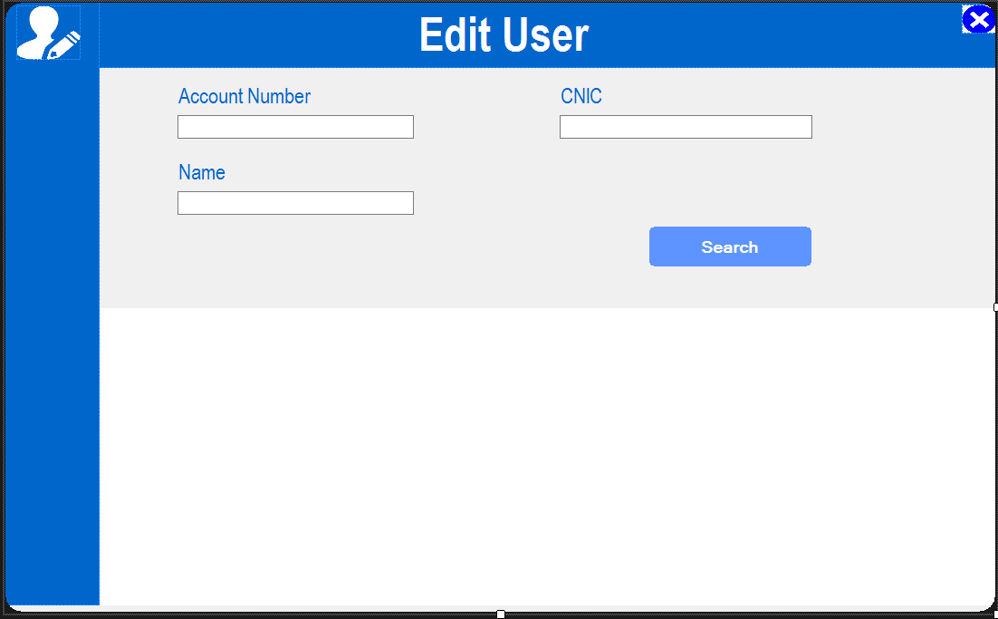

* Manage User Form

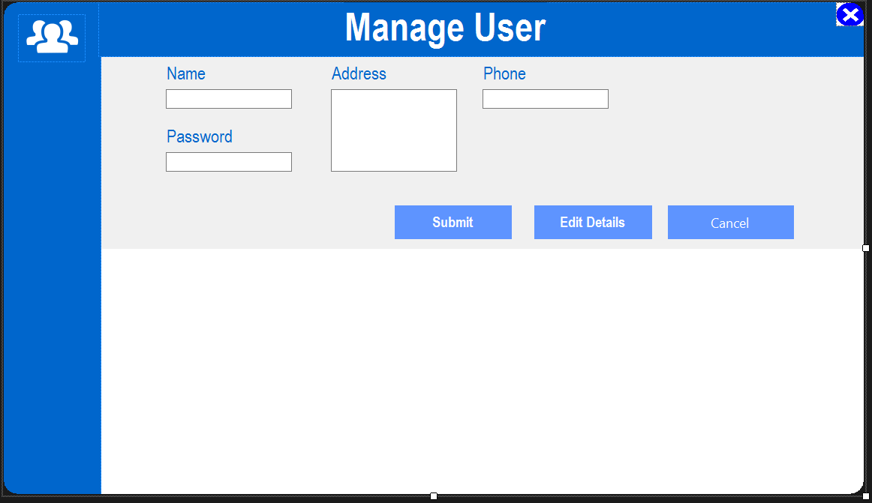

* Transaction Form

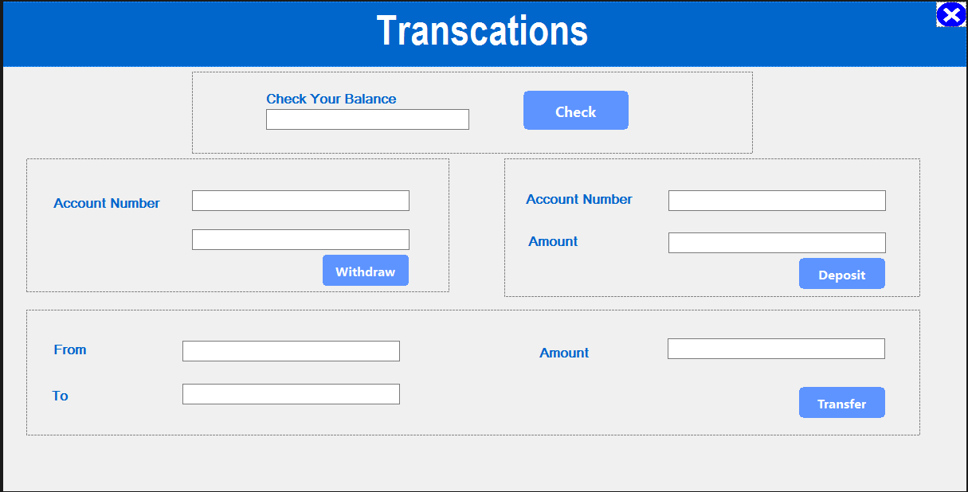

* Setting Form

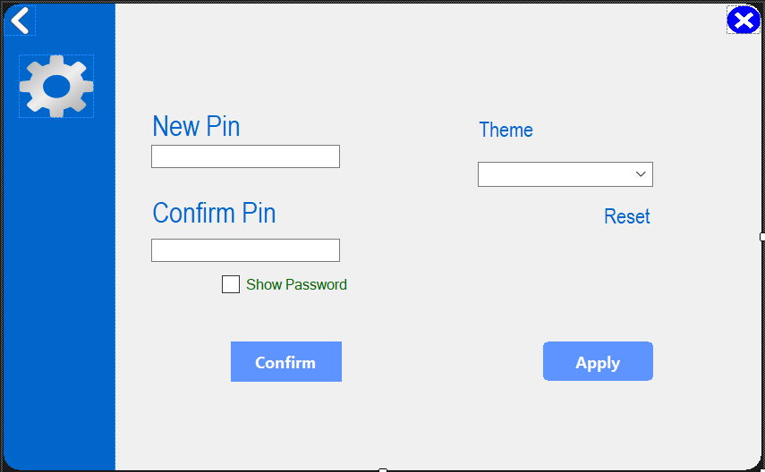

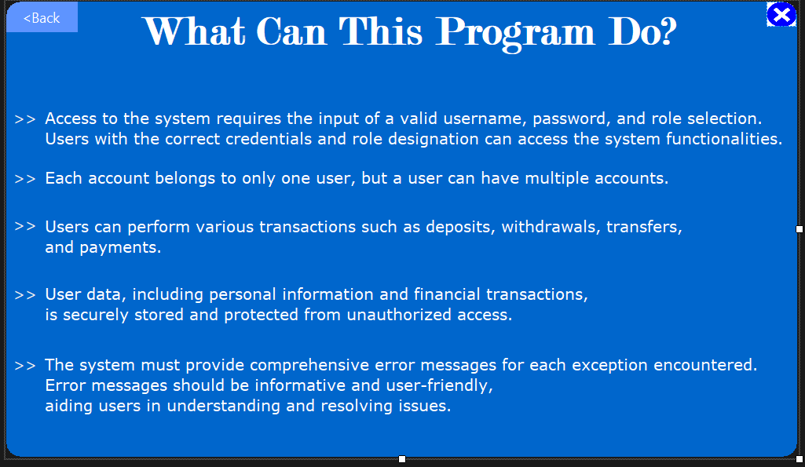

## Reports and Reports Layout

* Account Activity Report in Standard Layout.
* Transaction History Report in Standard Layout.
* User Activity Report in Standard Layout.
* Account Summary Report in Standard Layout.